

Foundations of Programming

Assignment No: 8

PROBLEM STATEMENT:
Write a program in C to accept marks of five courses of a student and compute the result. A student is considered PASS if he/she scores 40 marks or more in each course. If the student passes, calculate the aggregate percentage and assign the grade as follows:
- Aggregate ≥ 75% : Distinction
- Aggregate ≥ 60% and < 75% : First Division
- Aggregate ≥ 50% and < 60% : Second Division
- Aggregate ≥ 40% and < 50% : Third Division

OBJECTIVE:
- To understand the use of conditional statements in C
- To apply logical operators for decision making
- To calculate total, percentage, and grade of a student
- To enhance problem-solving skills using real-life scenarios

THEORY:
In academic evaluation systems, student performance is assessed based on individual subject marks as well as overall aggregate performance. In C programming, such evaluation systems can be implemented using conditional statements like if, else if, and else. Logical operators help in checking multiple conditions simultaneously. Percentage calculation involves arithmetic operations, and grading logic is implemented based on predefined ranges. This program demonstrates structured programming and decision-making in C.

ALGORITHM:
- Start
- Declare variables to store marks of five subjects, total marks, percentage, result, and grade
- Read marks of five subjects from the user
- Calculate total marks by adding all five subject marks
- Check if the marks in each subject are 40 or more
- If any subject mark is less than 40, set result as FAIL and go to Step 8
- If the student passes, calculate percentage as:
Percentage = Total Marks / 5
- Assign grade based on percentage:
- If percentage ≥ 75 → Distinction
- Else if percentage ≥ 60 and < 75 → First Division
- Else if percentage ≥ 50 and < 60 → Second Division
- Else if percentage ≥ 40 and < 50 → Third Division
- Display total marks, percentage, result, and grade
- Stop

CODE:
#include <stdio.h>

int main() {
int m1, m2, m3, m4, m5;
int total;
float percentage;
char result[5];
char grade[20];

// Read marks
printf("Enter marks of five subjects:\n");
scanf("%d %d %d %d %d", &m1, &m2, &m3, &m4, &m5);

// Calculate total marks
total = m1 + m2 + m3 + m4 + m5;

// Check pass/fail
if (m1 < 40 || m2 < 40 || m3 < 40 || m4 < 40 || m5 < 40) {
printf("\nResult: FAIL");
printf("\nTotal Marks: %d", total);
} else {
// Student passes
percentage = total / 5.0;

// Assign grade
if (percentage >= 75)
printf("\nGrade: Distinction");
else if (percentage >= 60)
printf("\nGrade: First Division");
else if (percentage >= 50)
printf("\nGrade: Second Division");
else
printf("\nGrade: Third Division");

printf("\nResult: PASS");
printf("\nTotal Marks: %d", total);
printf("\nPercentage: %.2f", percentage);
}

return 0;
}

FLOWCHART:
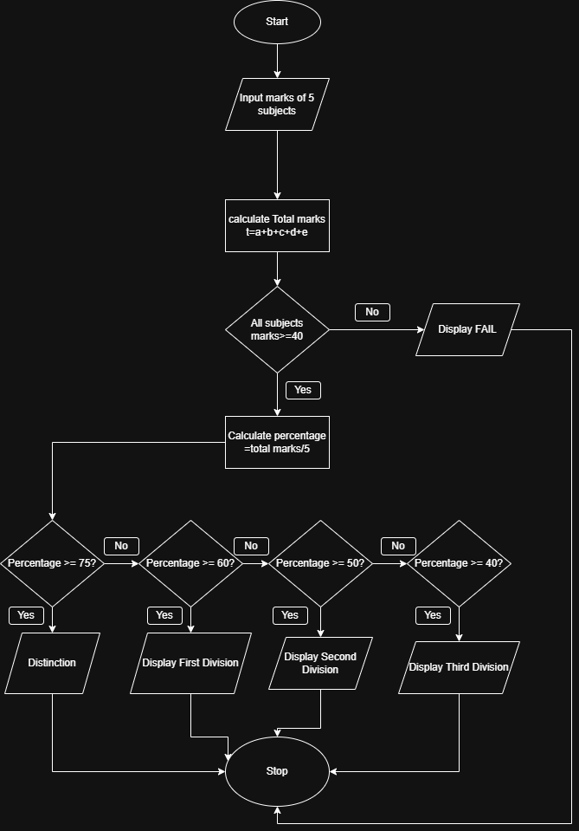

INPUT:
The user enters marks of five subjects.
Example Input:
Marks: 78 65 70 80 75
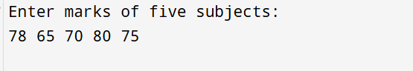

OUTPUT: The program displays the total marks, percentage, result, and grade.
Example Output:
Total Marks = 368
Percentage = 73.60%
Result: PASS
Grade: First Division
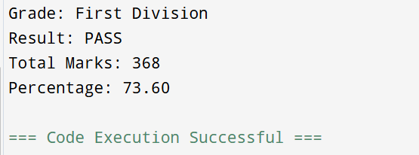

CONCLUSION: Thus, the program to calculate student result and grade based on marks was successfully implemented using C programming. This program demonstrates the effective use of conditional statements, logical operators, and arithmetic operations.

